2/19/2022

ONLINE EDUCATION

Abdullah Othman

**Online Education**



**Introduction**

**ONLINE EDUCATION:**

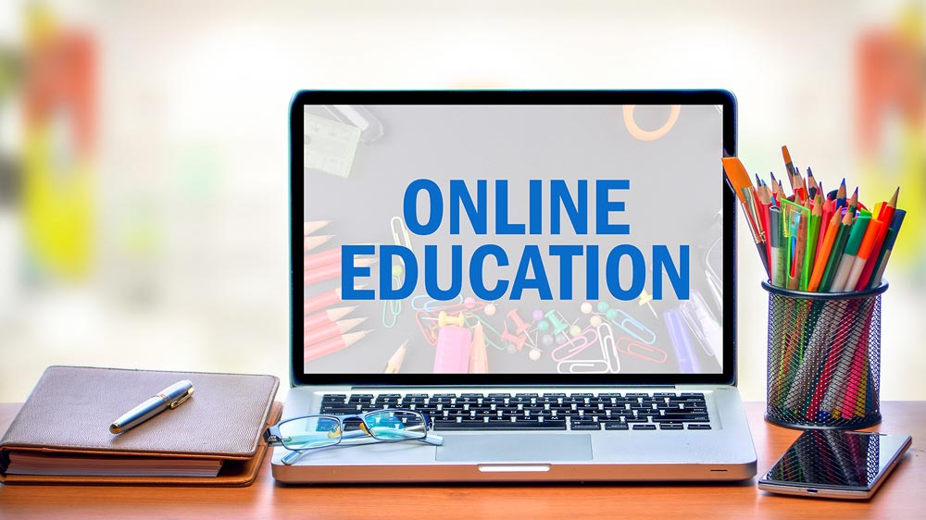

Online education is a flexible instructional delivery system

that encompasses any kind of learning that takes place via

the [Internet](https://www.encyclopedia.com/science-and-technology/computers-and-electrical-engineering/computers-and-computing/internet). Online learning gives educators an opportunity to reach students who may not be able to enroll in a traditional classroom course and supports students who need to work on their own schedule and at their own pace. Online learning is becoming a more traditional approach to achieving educational goals for a number of reasons.

Content:

* What are the advantages of online education?
* What are the disadvantages of online education?
* Comparison Table.
* feedback.

**Advantages Of Online Education**



**What are the advantages of online education?**

* Benefits of Online Education:

## **You Will Have Greater Flexibility When Scheduling Your Work**

When you choose to continue your education online, you will have greater flexibility to juggle your career, education, and home life without the confines of a fixed schedule. You will be able to log in and complete your course work, study, and do homework, all at times that can fit in with your schedule, instead of rearranging your schedule to work around traditional class times.

**You Have the Ability to Learn at Your Own Pace**

With online learning, you can set your own pace, which can provide you with a better chance of adequately absorbing and retaining the information in your coursework. Unlike traditional classes where you will need to take notes feverishly during lectures so that you can review the material later, online learning allows you to review the course materials as often as you like and at a time when you are most focused. Discussions and lectures will be in the form of video and podcasts, which can be watched, paused, and reviewed as needed so that you can make sure you are following along. It also provides you with the luxury of being able to complete materials in courses that are easier for you more rapidly, so you can take more time to focus on courses that you may find are more difficult.

## **You Will Spend Less Than a Traditional Classroom**

When learning from home, instead of a traditional classroom, you can save money in a number of ways. The first savings is the [money you can save](https://oedb.org/ilibrarian/10-advantages-to-taking-online-classes/) by not having to commute to class every day. Not only will you save on fuel and car maintenance, but you will also save on peripheral costs, such as parking. Additionally, the cost of tuition can be less than many brick and mortar institutions due to the fact that the school will not have the overhead costs of maintaining a classroom setting.

**Others:**

**- You Can More Easily Communicate With Your Professor.**

**- You Will Be Able to Easily Access Any Needed Documentation.**

**- You Will Gain New Technical Skills.**

**- And many other advantages.**

**Disadvantages Of Online Education**



**What are the advantages of online education?**

* Disadvantages of Online Education:

**Lose Concentration:** Without having proper care for students while online lasses by teachers they can easily lose focus on studies. Also, virtual classes can be done through phone or laptop gadgets where students can easily move to games or videos or youtube for entertainment. This completely makes them go off track from subject studies.

**Health Issues:**Many parents are worried about their child’s health as it is unhealthy to sit for hours in front of a computer screen. Looking at the screen for too long can also damage their eyesight. Not only that, back problems due to incorrect sitting positions may arise.

**Expensive:** We know that you have been confused after seeing this disadvantage. As we have said earlier that it is less in cost but it is also expensive for economically weaker students. Parents who are jobless due to covid can not afford smartphones or computers for students’ online learnings. In such cases, digital learning may be accessible but it’s not readily affordable.

**Lack of socializing skills:** As there is no socializing included in digital learning several students who study through digital mode can not acquire socializing skills. Also, it may lead to a decrease in the cooperative skills of a student.

**Isolation:**While digital education has its perks many students feel a sense of isolation and become depressed. This is due to little to no human contact and socializing with peers. Both students and teachers alike are prone to loneliness in virtual learning.

**Limited:** Digital learning does not apply to all disciplines and subjects. Areas that require practicals like engineering, medical science, and other STEM subjects cannot be implemented fully with digital classes. Moreover, some practicals cannot be learned virtually.

**Lack of Good Internet connection:** As we all know that online classes/learning are more flexible and accessible from anywhere conveniently with the help of a good internet connection. If you are failed to connect your phone or computer with good internet connectivity, then you may miss a lot of important stuff because of buffering. Also, for a good internet connection parents need to spend money on a monthly or yearly basis which is a disadvantage for poor and middle-class families.

**There are also many other disadvantages of online education.**

**Comparison Table**



### **Comparison Table for Advantages & Disadvantages of Online Classes:**

|  |  |
| --- | --- |
| **Advantages** | **Disadvantages** |
| Increased convenience and flexibility | Lack of practice-based learning |
| Builds confidence in a child | Difficulty in adapting |
| Improved employee knowledge | Less personal |
| Ease of content update | Too much time spent in front of a computer screen may be harmful |
| Interactive session | Not easily accessible |
| Reduced costs | Not suitable for every topic |
| Less Intensity | Excess exposure to screen time |
| The comfort of your Home | Requires self-discipline and time management skills Diminished social interaction |
| Easier Attendance | ack of trust between teacher and students |

Video link :

https://www.youtube.com/watch?v=ZfsooWtSw7s&ab_channel=SpanishFork17

Another video link :

https://www.youtube.com/watch?v=BUUQkCXJ6ns&ab_channel=JacquelynAnderson

**Feedback**



***Send us feedback:***

|  |
| --- |
|  |

Name:

|  |
| --- |
|  |

Mail:

|  |
| --- |
|  |

Feedback:

You agree about all the terms

You are responsible about the content of the mail.

I’m not a robot.

|  |
| --- |
| Reset |

|  |
| --- |
| Submit |